# Department of Computer Engineering

**Academic Term: Jan-May 23-24**

**Class:** B.E Computer Sem -VII **Subject:** Blockchain Technology Lab **Subject Code :** CSDL7022

|  |  |
| --- | --- |
| **Practical No:** | 7 |
| **Title:** | Creating Smart Contract in Ganache using Remix IDE |
| **Date of Performance:** | 08/09/23 |
| **Date of Submission:** | 08/09/23 |
| **Roll No:** | 9427 |
| **Name of the Student:** | Atharva Prashant Pawar |

**Evaluation:**

|  |  |  |
| --- | --- | --- |
| **Sr. No** | **Rubric** | **Grade** |
| **1** | **Time Line (2)** |  |
| **2** | **Output (3)** |  |
| **3** | **Code optimization (2)** |  |
| **4** | **Post lab (3)** |  |

**Signature of the Teacher :**

# Experiment No. 7 Blockchain platform Ganache.

**Aim:** Creating Smart Contract in Ganache using Remix IDE

# Theory:

**Step 1:**

# Installation ganache

Download and Install ganache from <https://github.com/trufflesuite/ganache-ui/releases>

This is for Windows OS, you can choose the download file as per your System OS Compatibility.

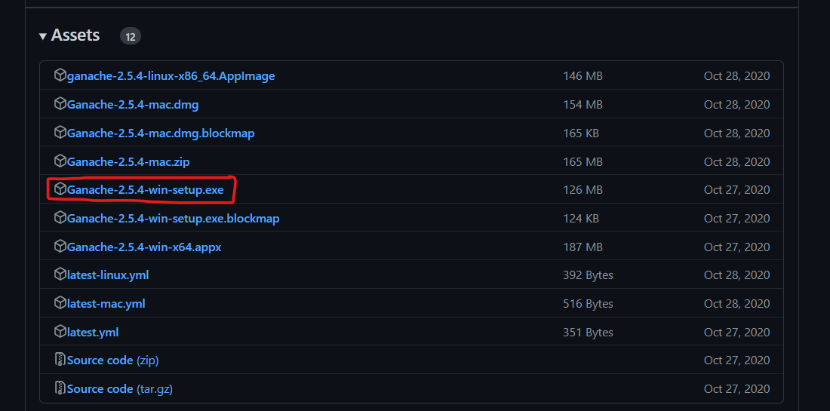

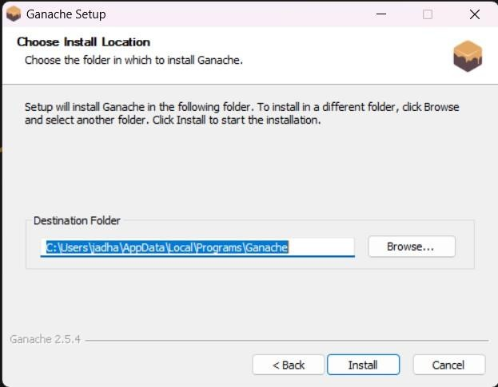

# Step 2:

After installing, open Ganache and you will see this window.

Create Workspace by clicking on QuickStart

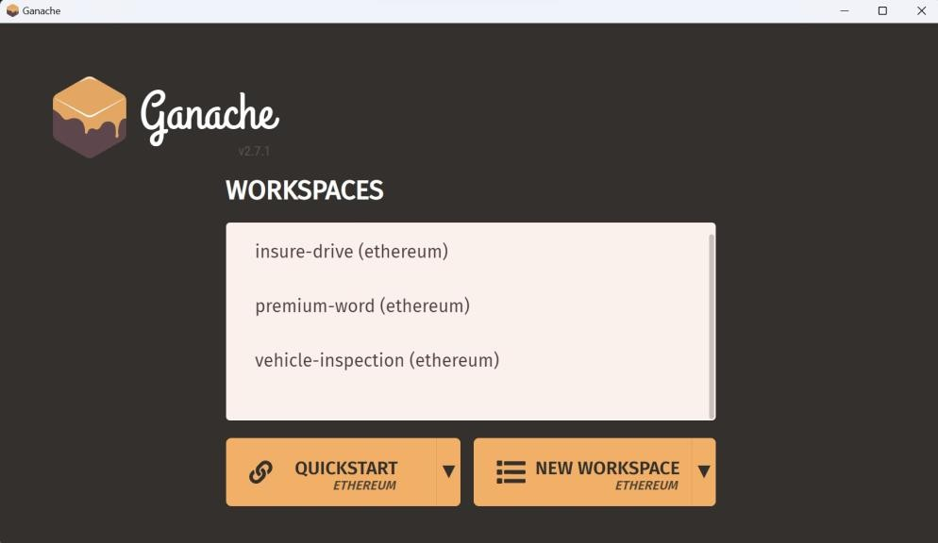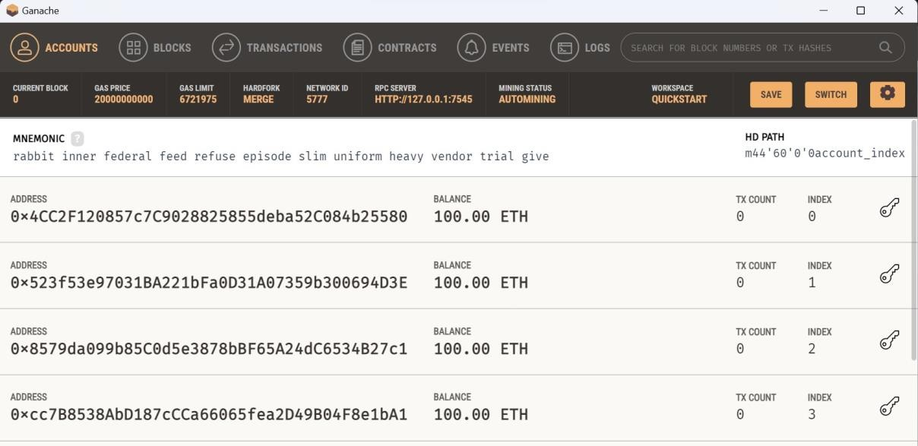

You can see here a list of accounts along with their address, balance, and other information. In the header, you can see blocks, transaction information, etc. Observe RPC SERVER Address here, with this address you will be interacting with this blockchain.

**Step 3:**

**Installation of MyEtherWallet**

MyEtherWallet is an online wallet & client-side interface, which can interact with Ethereum blockchain & perform operations on the blockchain. But here we are using private blockchain running in our local, which can’t be accessed by an online version, so we will download it from <https://github.com/kvhnuke/etherwallet/releases>and run it locally.

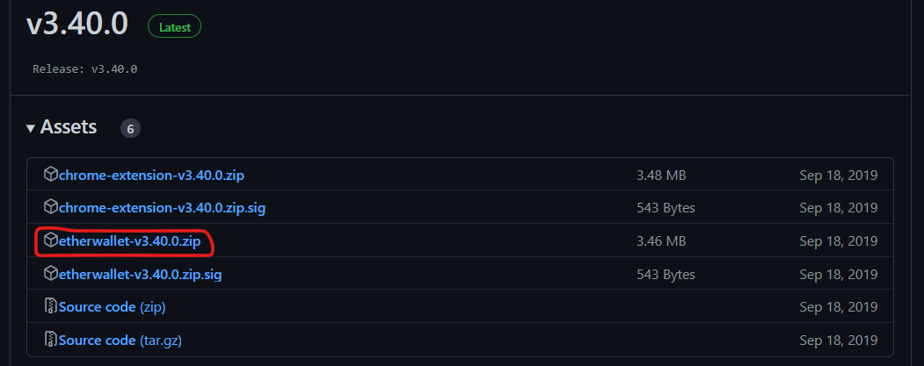

You can download the latest release, unzip it, and open index.html.

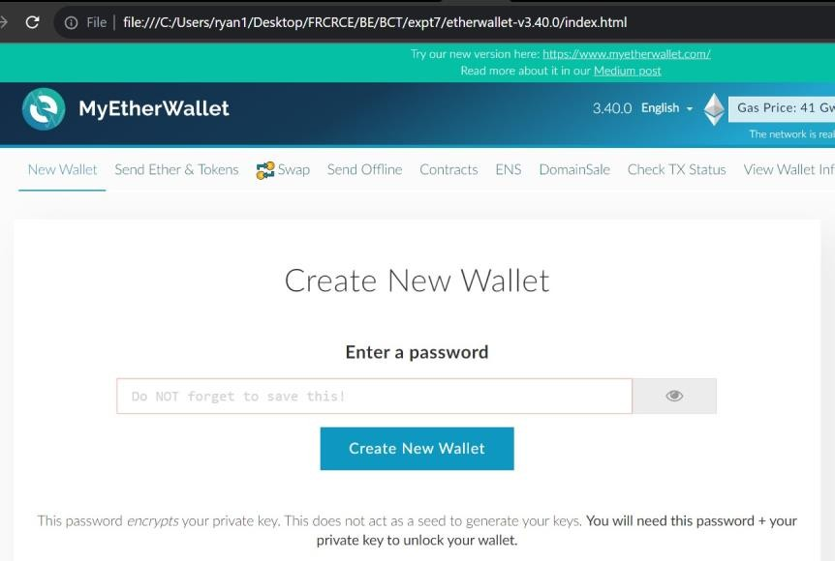

# Step 4:

**Write Smart Contract in Solidity**

**Open Remix IDE** <https://remix.ethereum.org/>

We will use it to write and compile our smart contract code.

pragma solidity ^0.4.24; contract Calculator {

int private lastValue = 0;

function Add(int a, int b) public returns (int) { lastValue = a + b;

return lastValue;

}

function Subtract(int a, int b) public returns (int) { lastValue = a - b;

return lastValue;

}

function LastOperation() public constant returns (int) { return lastValue;

}

}

In the above code you can see there is one field *lastValue*, which stores the last operation performed. Here LastOperation has a constant keyword, but add and subtract do not. because LastOperation doesn’t change the state whether or not add and subtract are mutating it.

Open [Remix IDE](https://remix.ethereum.org/) and replace the existing code with the above one. Then click *Start to compile* and if it compiles successfully, you can see your contract name (Calculator here) in the green box, below the details button. On click of the details button, you can see all the data about the compiled contract, including generated byte code, which we will be using further.

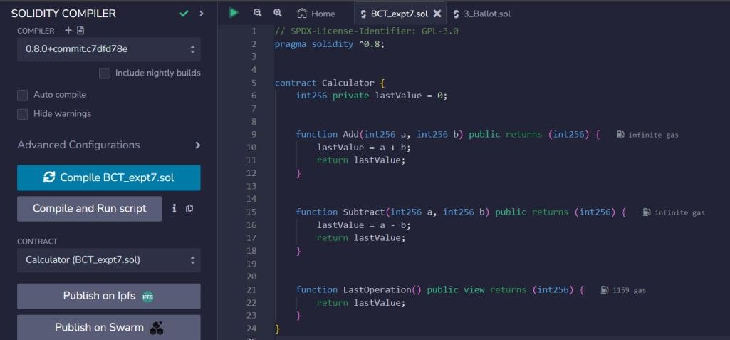

Your code is compiled successfully, now let’s deploy and test it.

# Step 5:

**Deploy Smart Contract to Private Ethereum Blockchain & Test It**

We will deploy it to blockchain running in Ganache with the help of MyEtherWallet. Open Ganache and grab *RPC SERVER* URL.

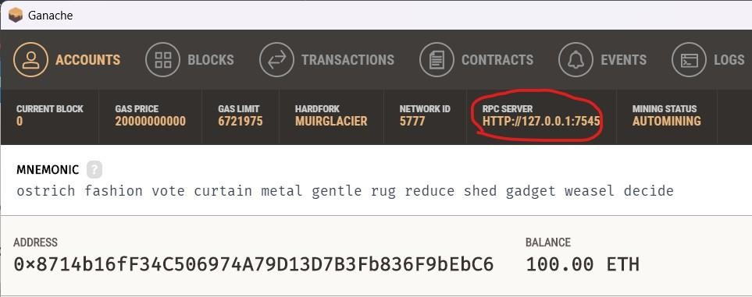

Now, open index.html of MyEhterWallet, and connect to this blockchain. To do this click on dropdown as shown in the image and select Add Custom Network/Node

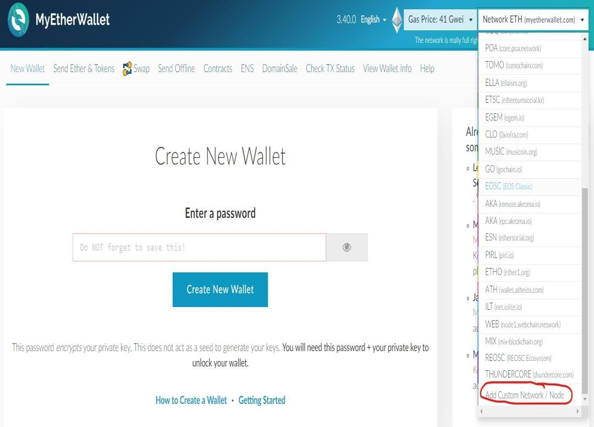

You will see the success message on the bottom.

Now go to contacts in the menu and click deploy the contract, here you need Byte Code of your smart contract to deploy, which we will get from details of the contract in Remix IDE.

Go back to Remix IDE, click on details & copy BYTECODE.

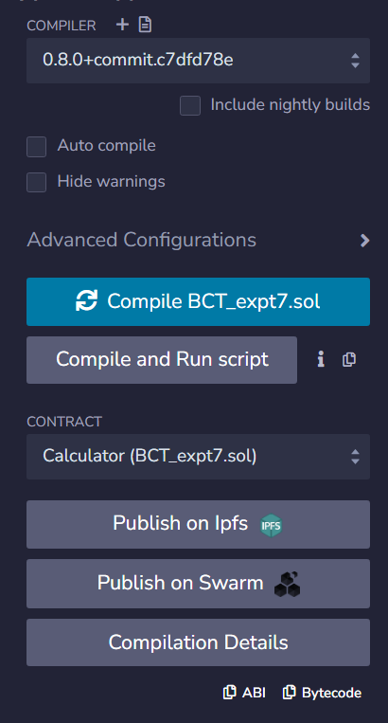

We need to pick the contents of *an object*, copy it, and paste in Byte Code in Deploy Contract in MyEtherWallet.

Right after pasting Byte Code, Gas Limit should appear. To access your wallet, MyEtherWallet needs a private key. Wallet? Yes, let me explain wallet to you in the next step.

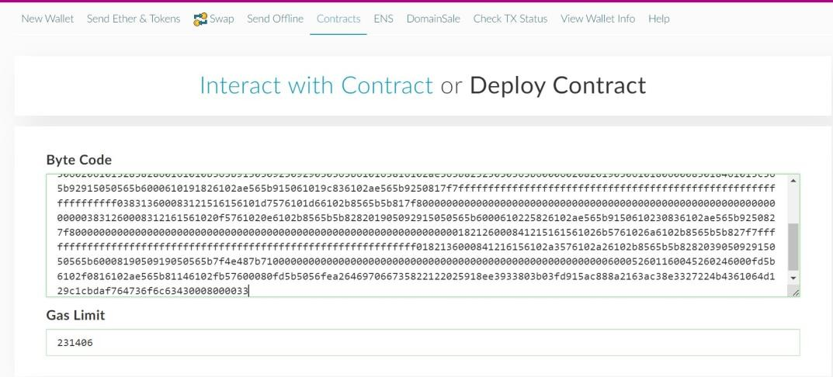

To access your wallet, MyEtherWallet needs a private key. Ganache will have a few accounts created by default. The place where the information about the account is stored is referred to as a wallet. We will use one of those accounts.

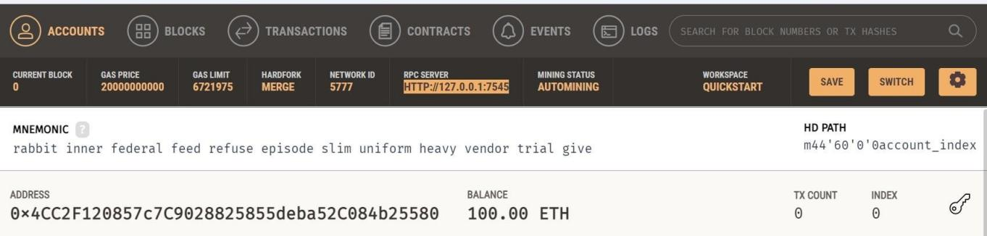

Open Ganache and copy a key from one of the wallets.

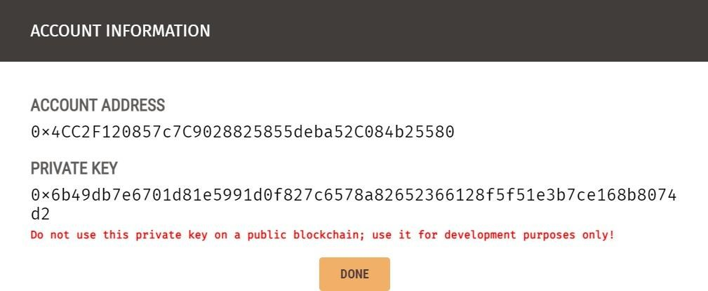

Now, use this in the MyEtherWallet, and click **Unlock**.

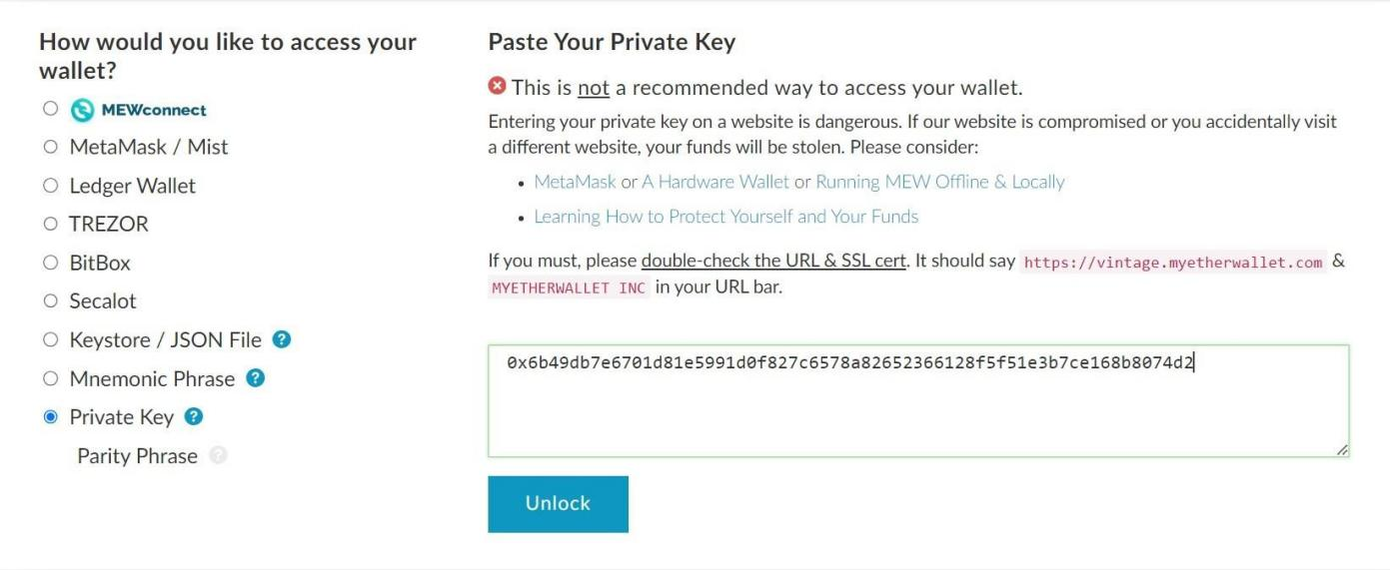

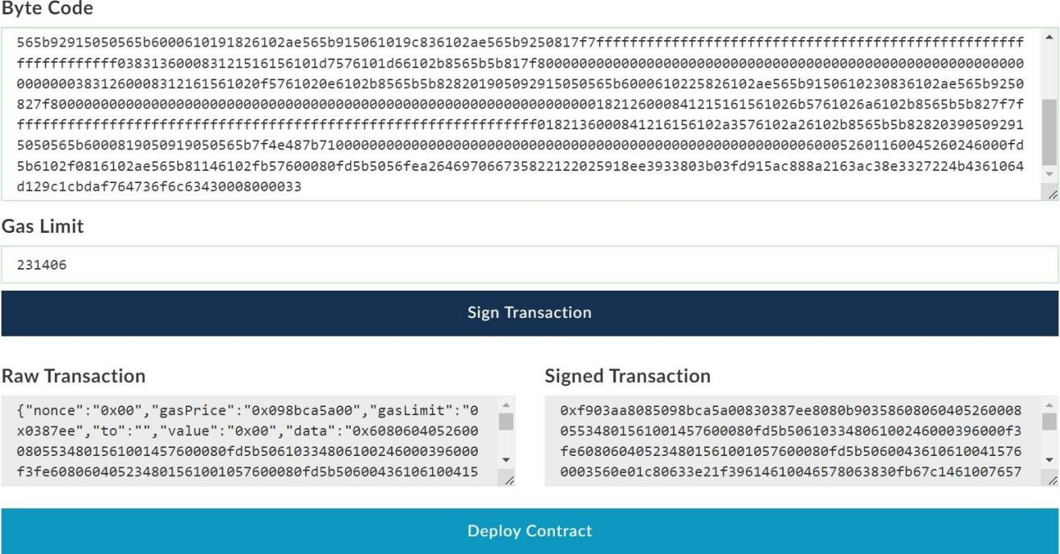

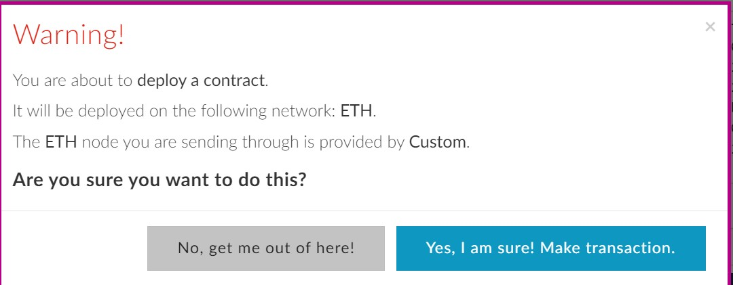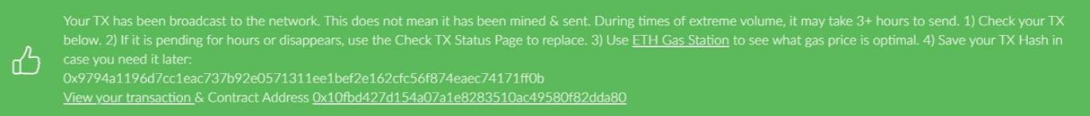

Let’s verify in Ganache whether it’s deployed successfully. Go to transactions in Ganache, here you can see one *Contract Creation* transaction is created in a block. Congrats! Your smart contract is deployed successfully.

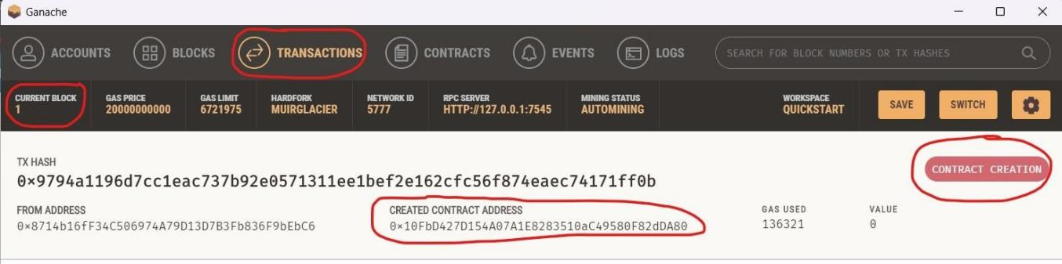

Let’s test it now, click to open the above-shown transaction, and copy **CREATED CONTRACT ADDRESS**. Go to MyEtherWallet & under Contracts, click Interact with Contract, paste the Contract Address here.

For the ABI interface, you need to go to Remix IDE then details, get ABI form here and paste. ABI interface contains information about functions available in a smart contract.

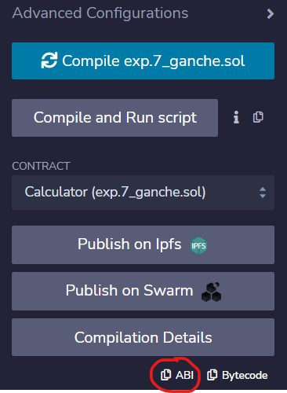

After clicking Access, you can see all available functions in your smart contract.

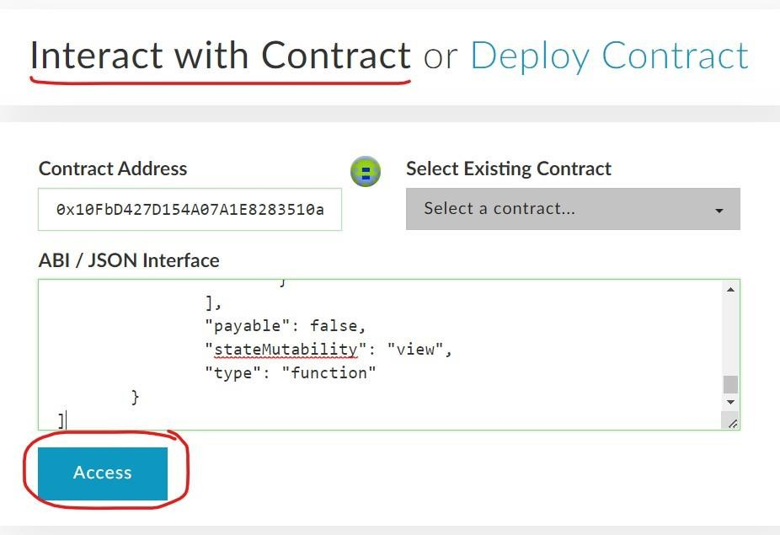

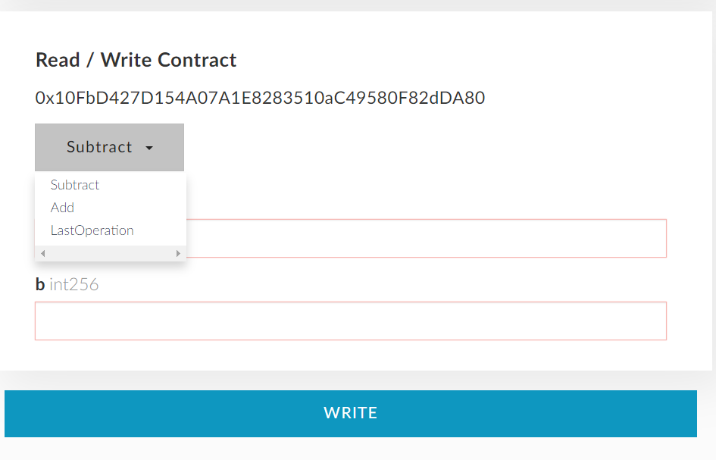

Let’s call them and test.

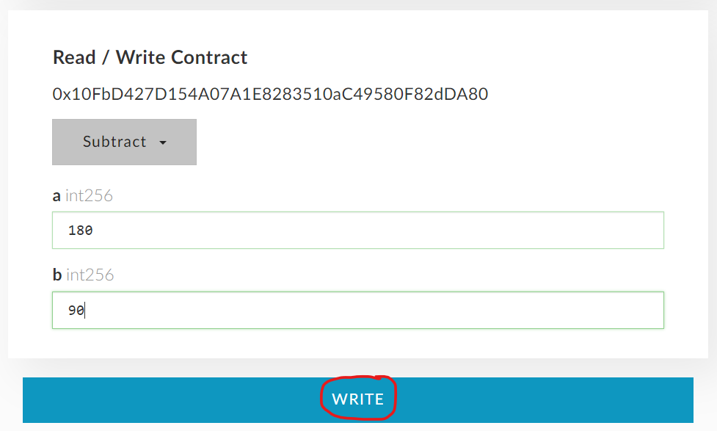

While calling Add or Subtract, it will show a warning before making a transaction, along with the gas limit.

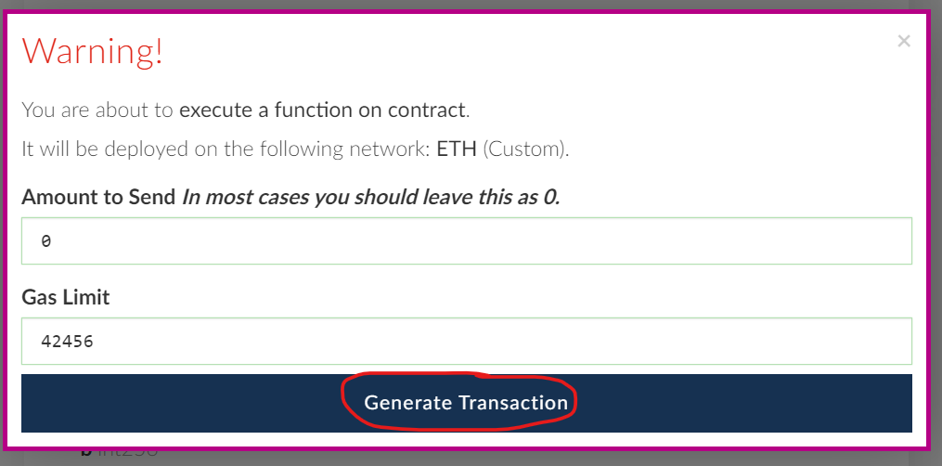

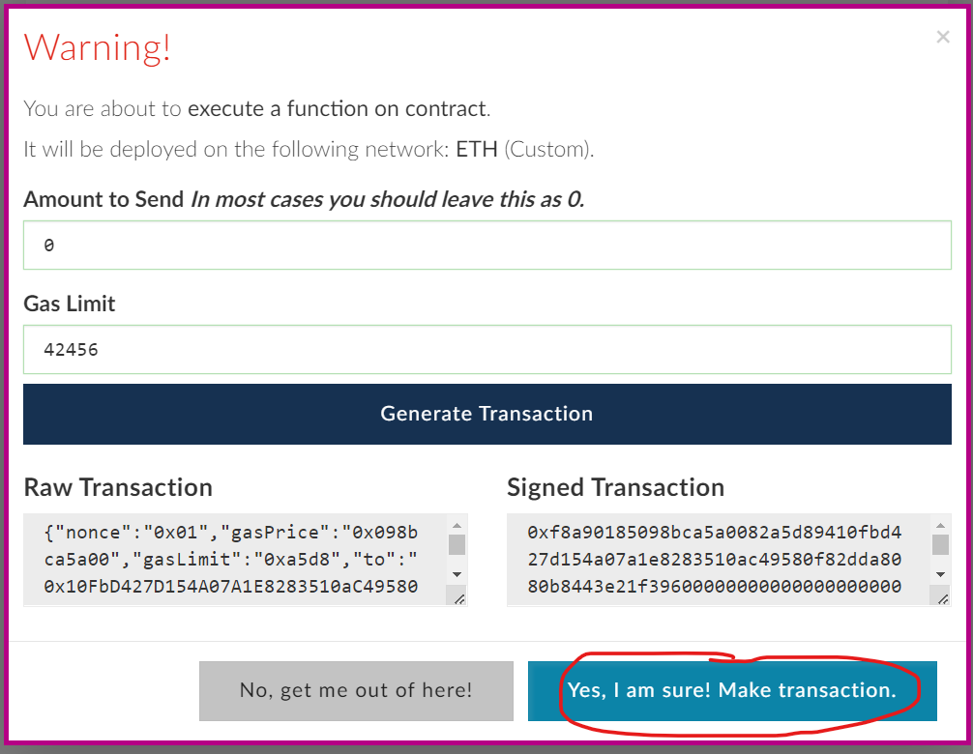

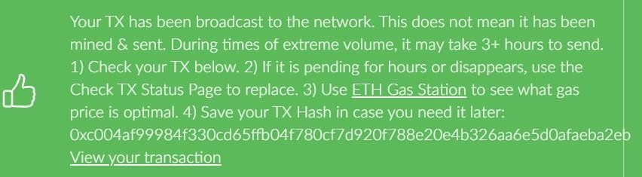

But in LastOperation no warning will appear because it adds no data to the blockchain.

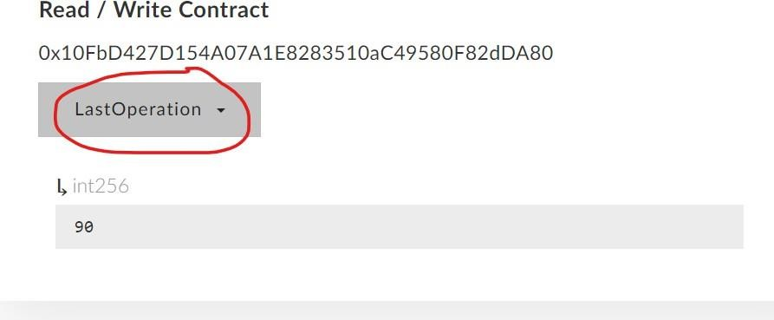

**Conclusion:** We have used ganache to perform transactions with smart contract by using ganache Platform.

